

**AERO CLUB of BUFFALO**

# Long Sleeve Tee

**T-Shirt**

**1/4-Zip Pullover**

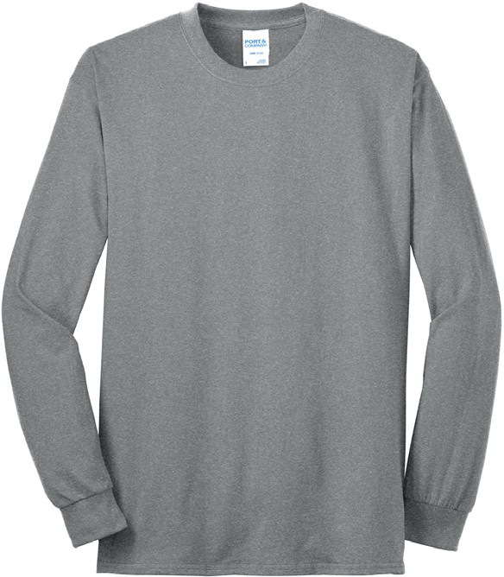

$20.00

SIZE: S, M, L, XL, 2XL

COLOR: Royal BLue, Athletic Heather, Black

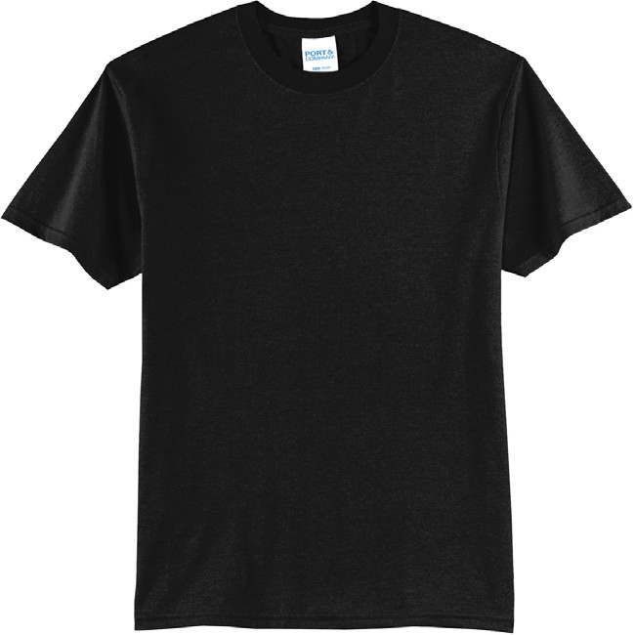

$16.00

SIZE: S, M, L, XL, 2XL

COLOR: Royal BLue, Athletic Heather, Black

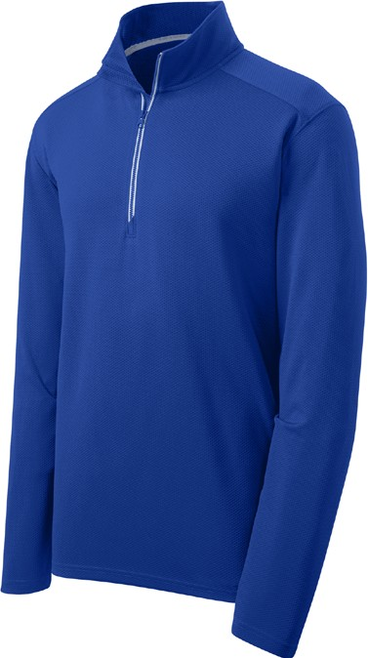

$35.00

SIZE: XS, S, M, L, XL, 2XL

COLOR: Royal BLue, Athletic Heather, Black

|  |  |  |  |  |
| --- | --- | --- | --- | --- |
|  | ITEM TYPE | COLOR | SIZE | PRICE |
| ITEM 1 |  |  |  |  |
| ITEM 2 |  |  |  |  |
| ITEM 3 |  |  |  |  |
| ITEM 4 |  |  |  |  |
| ITEM 5 |  |  |  |  |
| ITEM 6 |  |  |  |  |

ORDER TOTAL: $

NAME: PHONE NUMBER: METHOD OF PAYMENT:

CARD NUMBER/CHECK NUMBER: EXP. DATE: CVV: